**Athif Zakiyanto_QE Kelas A**

**Weekly Task QE 2**

**Positive Test Case**

* Test Case User

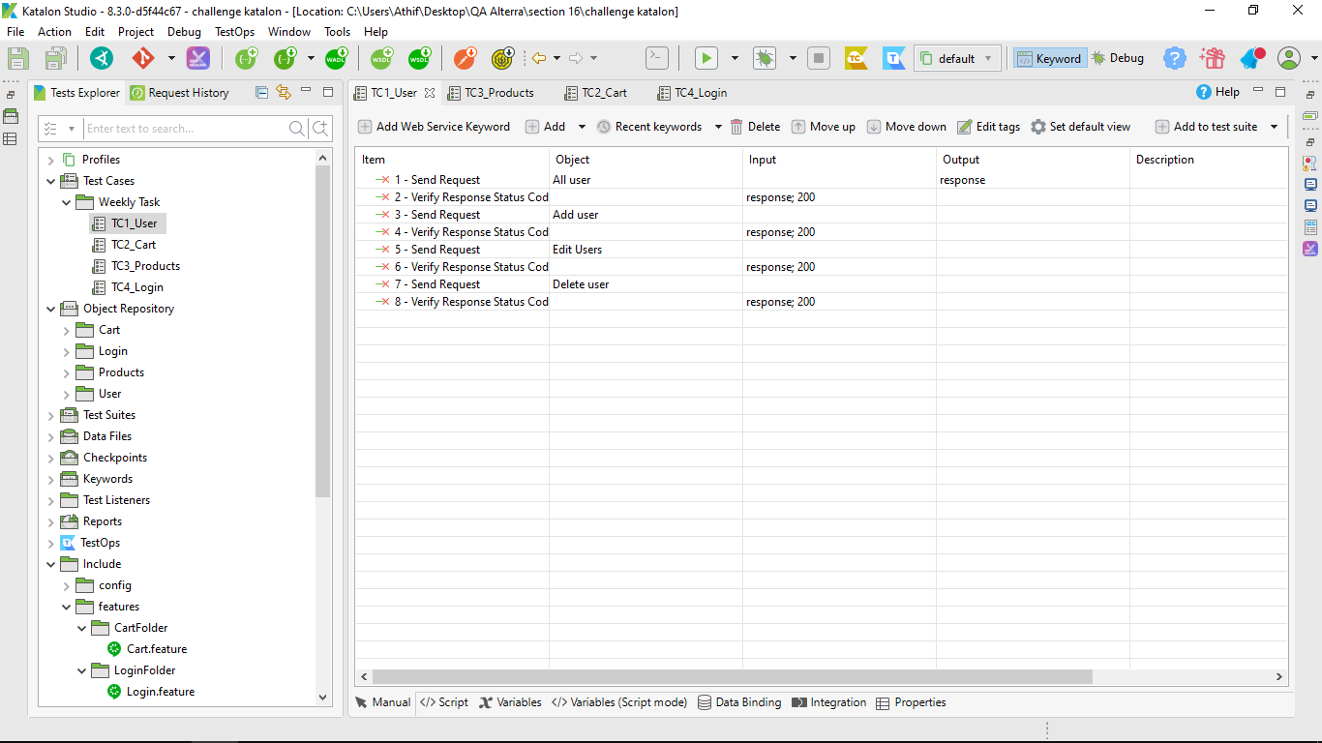

* Test Case Cart

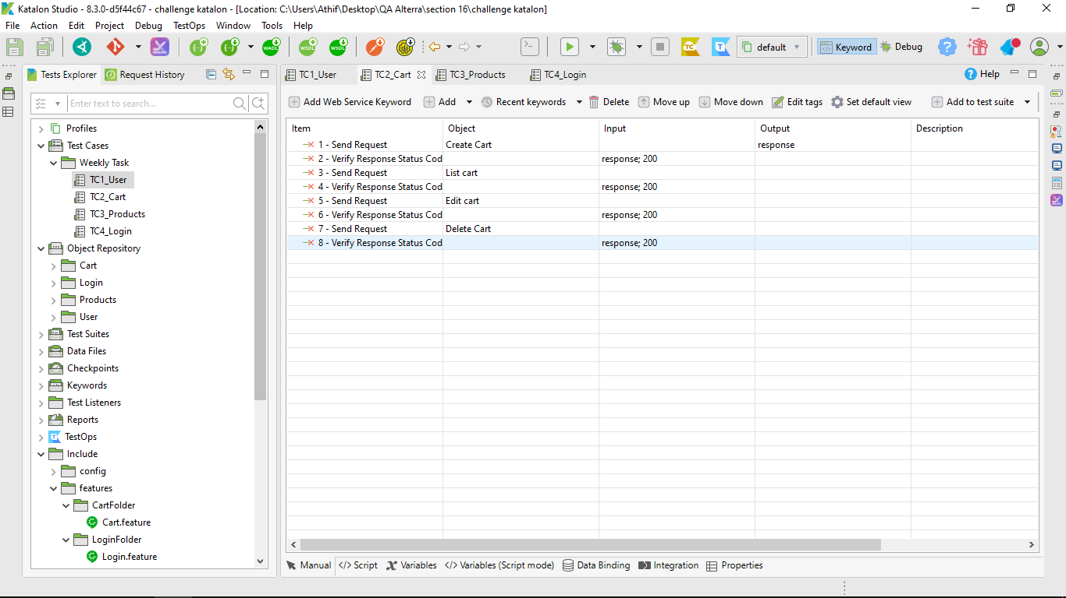

* Test Case Product

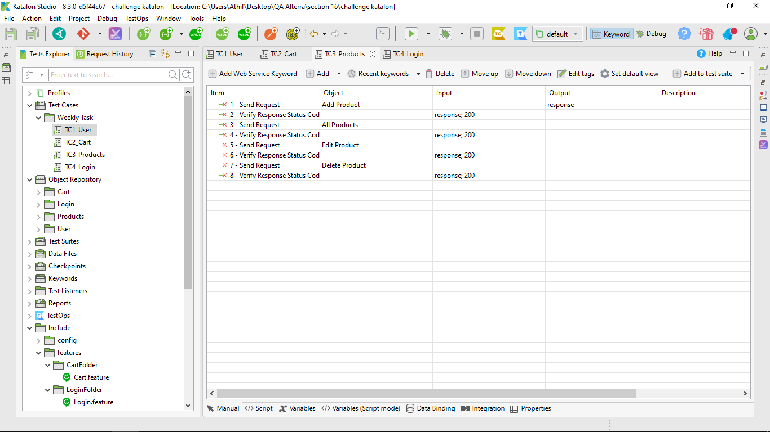

* Test Case Login

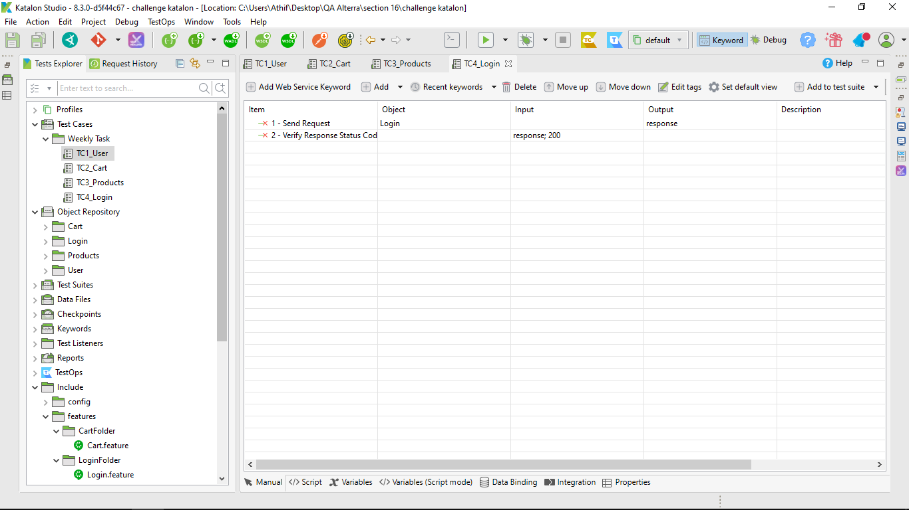

**Negative Test Case**

* Test Case Negative User

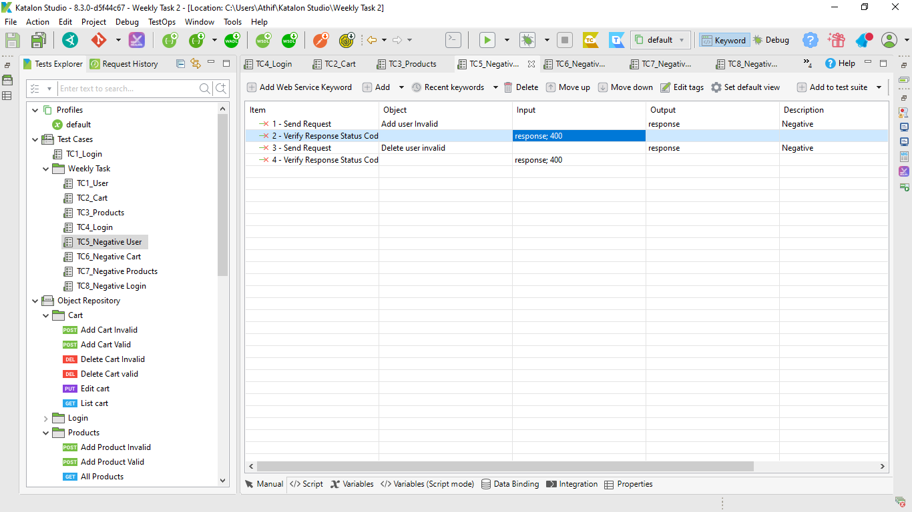

* Test Case Negative Cart

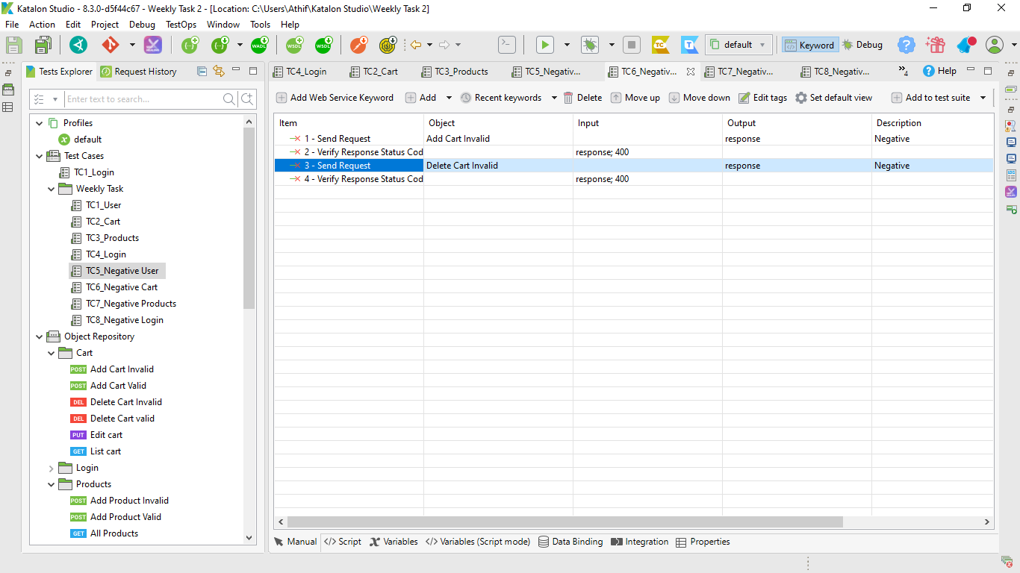

* Test Case Negative Product

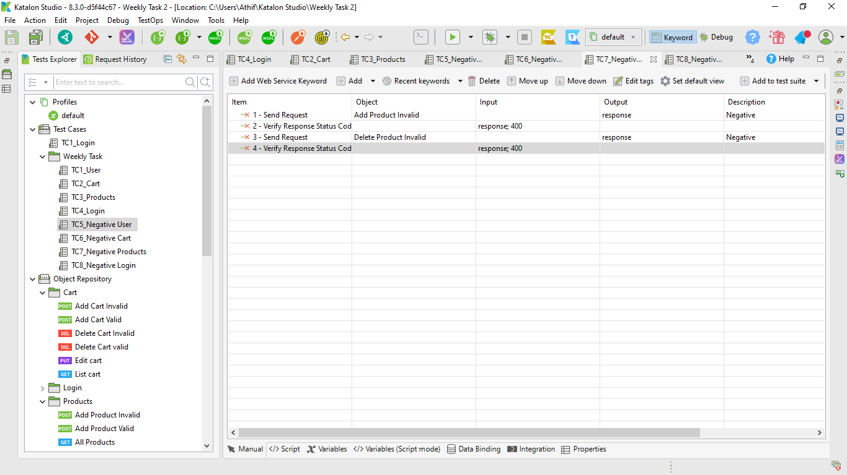

* Test Case Negative Login

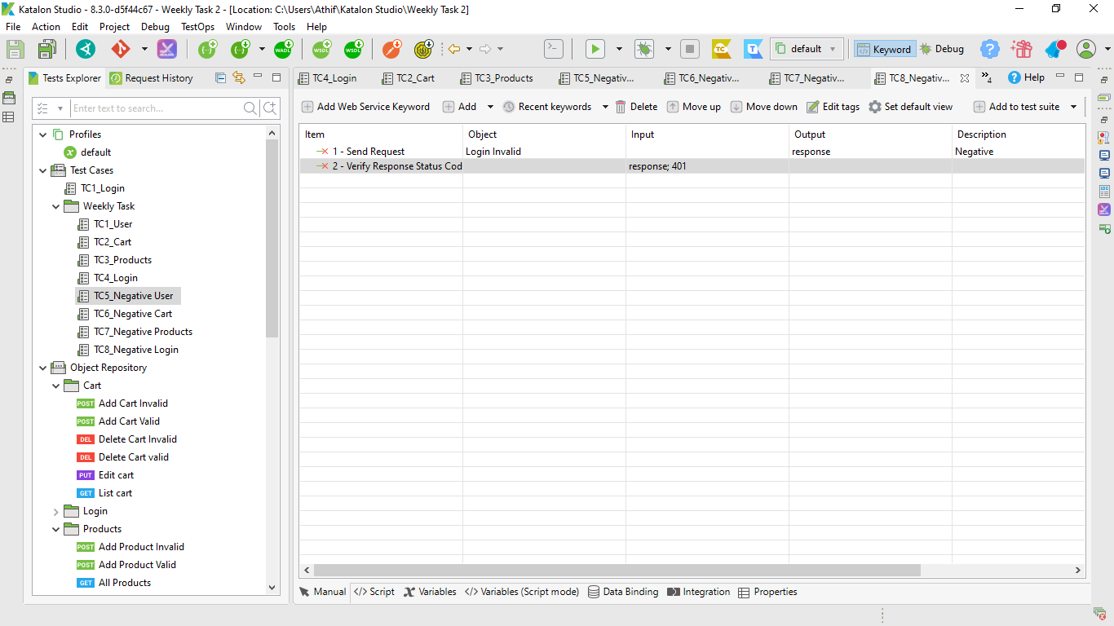

**API Test Fitur Cart**

* POST Add Cart valid data(https://fakestoreapi.com/carts)

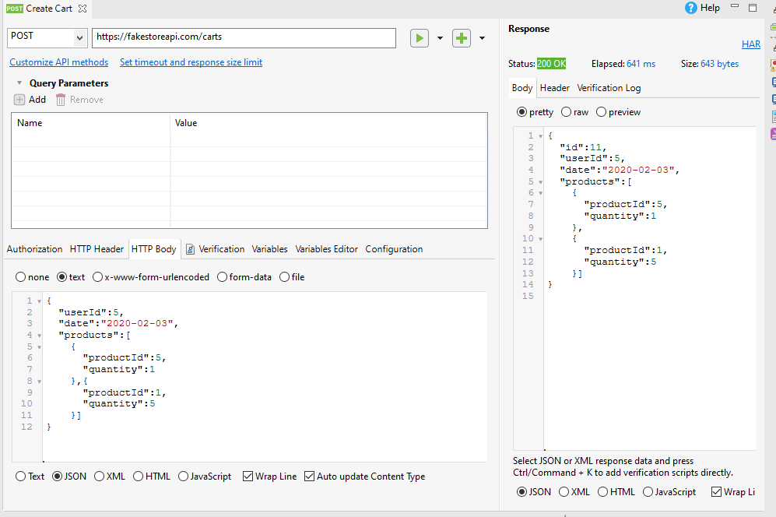

* POST Add Cart Invalid data(https://fakestoreapi.com/carts)

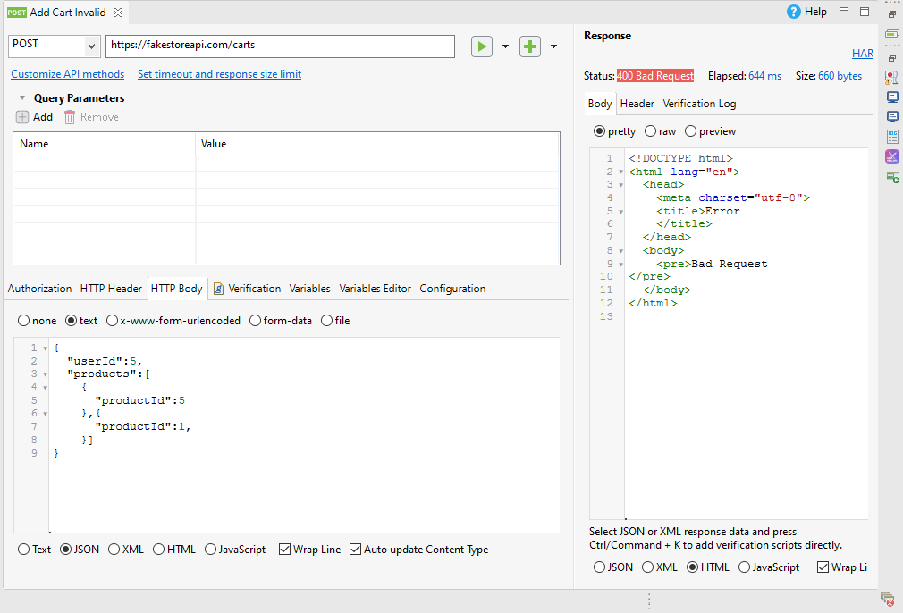

* GET List Cart (https://fakestoreapi.com/carts)

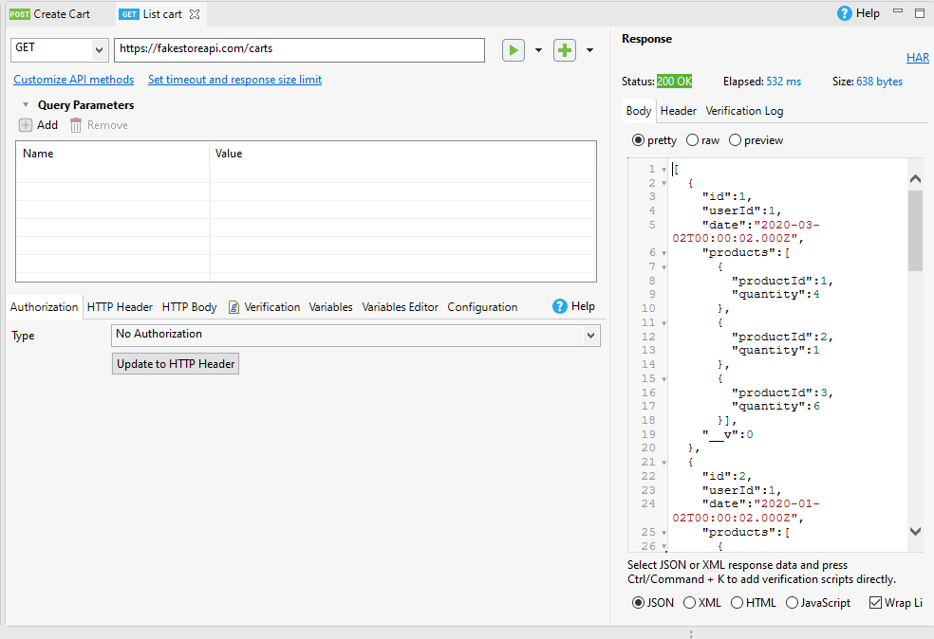

* PUT Edit Cart (https://fakestoreapi.com/carts/7)

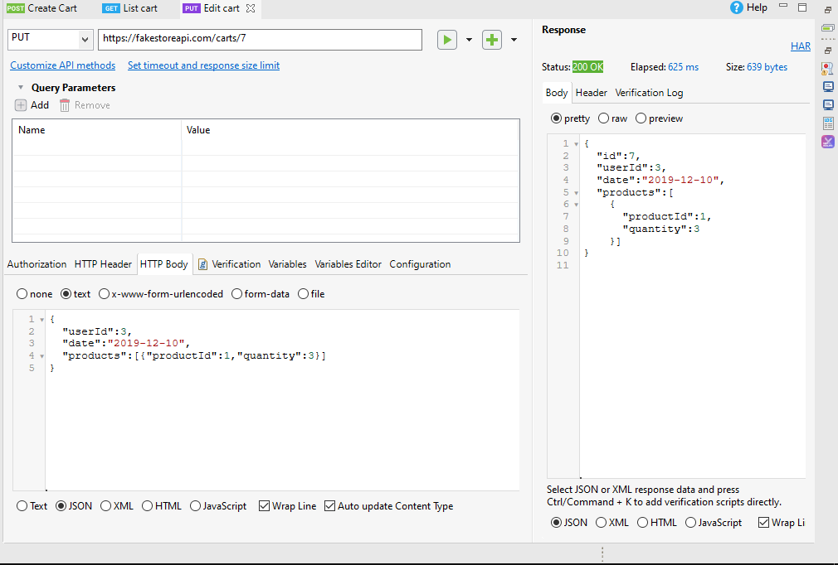

* DELETE Cart valid id(https://fakestoreapi.com/carts/6)

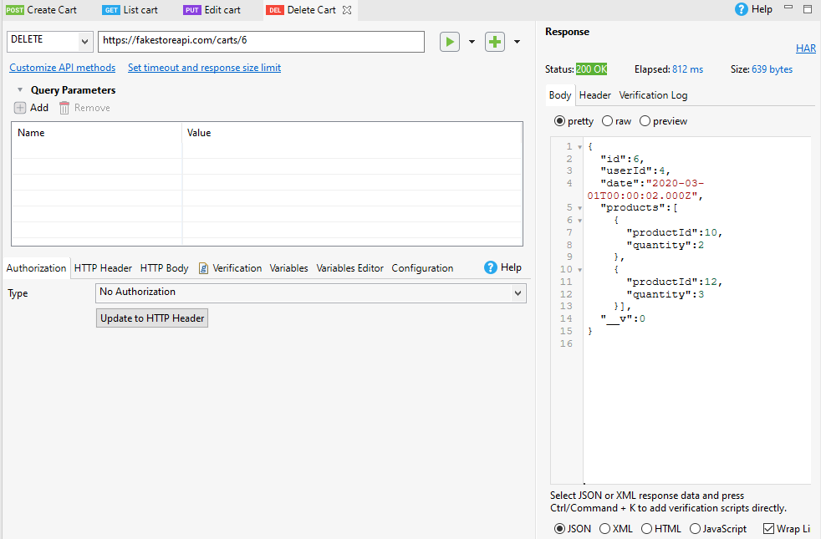

* DELETE Cart invalid id(https://fakestoreapi.com/carts/c)

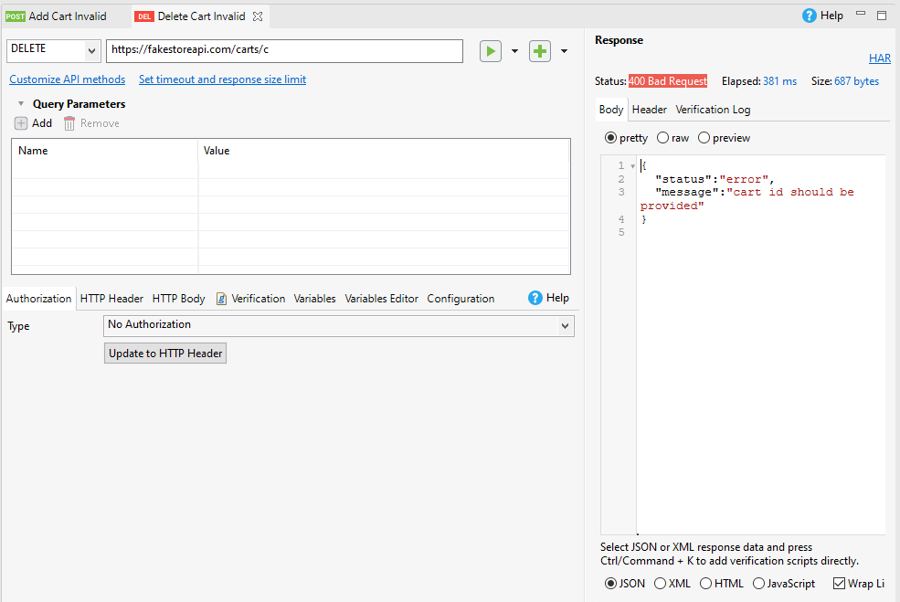

**API Test Fitur User**

* POST Add user valid data(https://fakestoreapi.com/users)

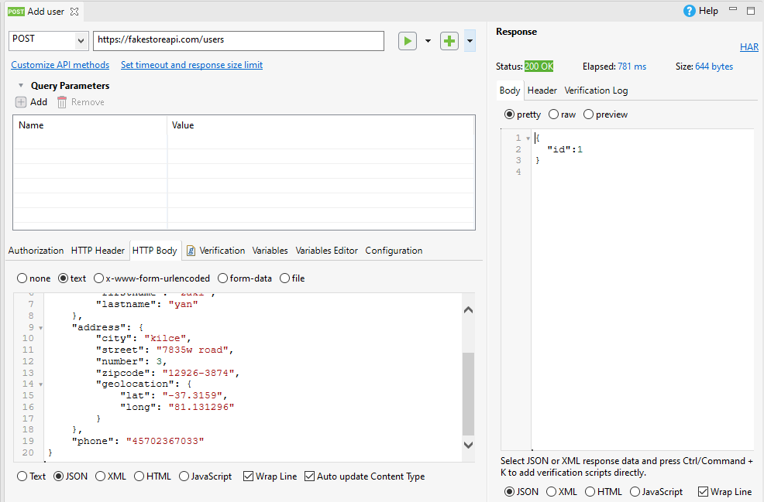

* POST Add user invalid data(https://fakestoreapi.com/users)

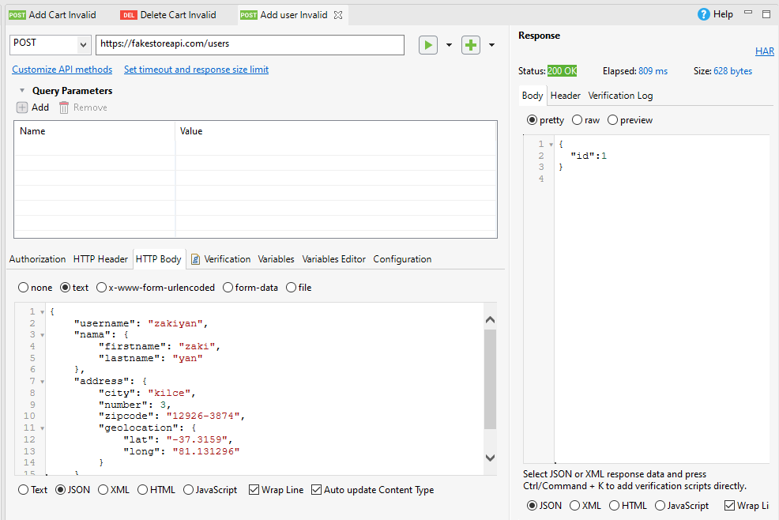

* GET All User (https://fakestoreapi.com/users)

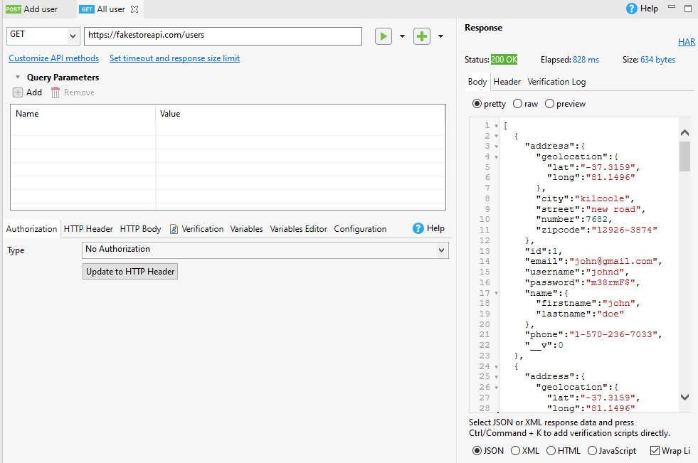

* PUT Edit User (https://fakestoreapi.com/users/7)

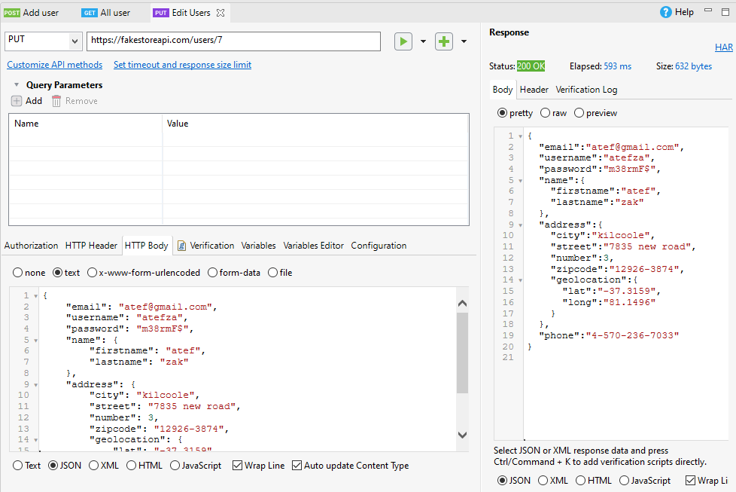

* DELETE User valid id (https://fakestoreapi.com/users/6)

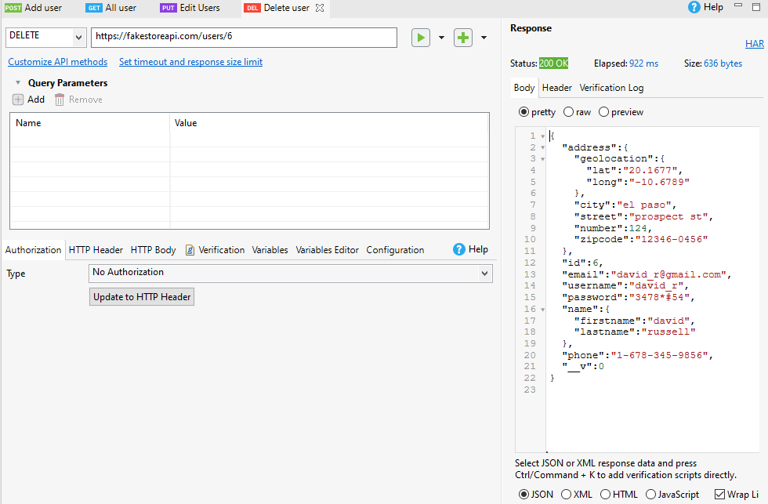

* DELETE User Invalid id (https://fakestoreapi.com/users/g)

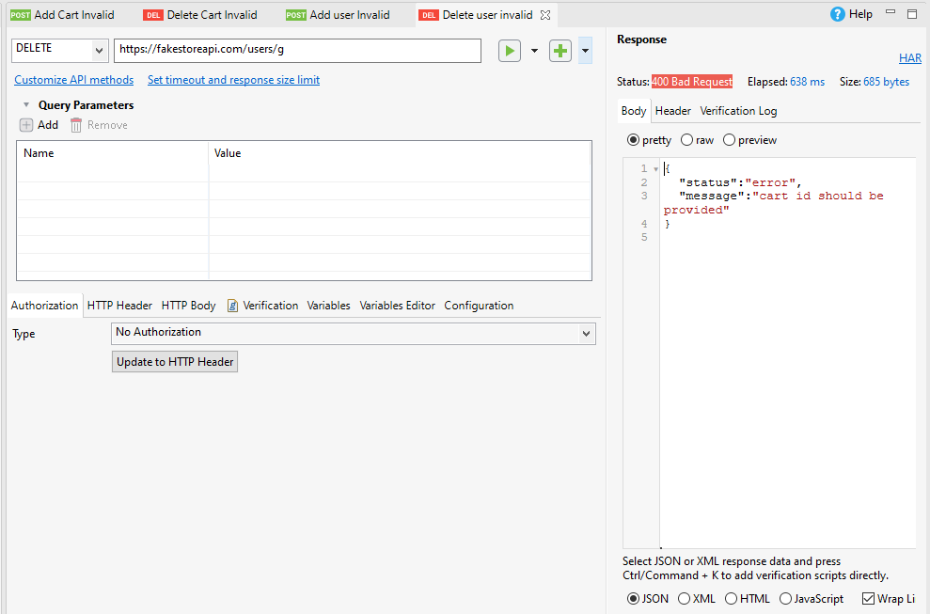

**Test API Fitur Product**

* POST Add Product valid data (https://fakestoreapi.com/products)

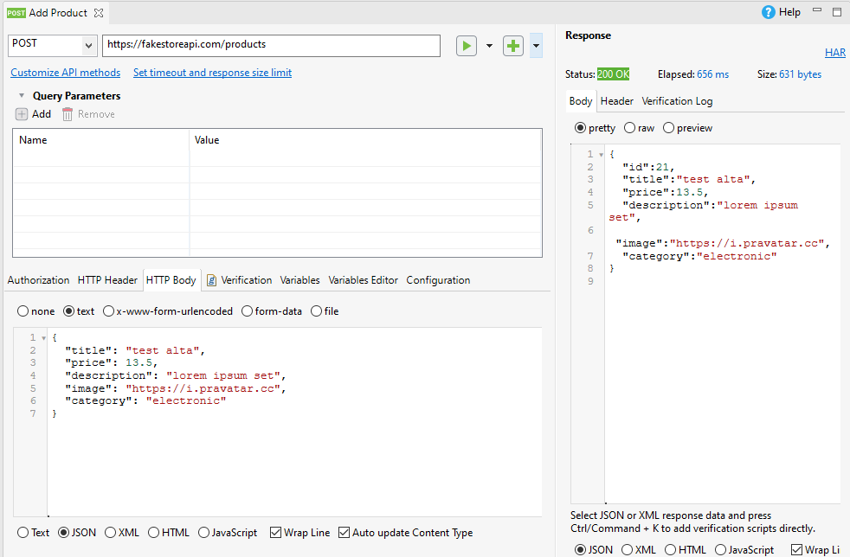

* POST Add Product Invalid data (https://fakestoreapi.com/products)

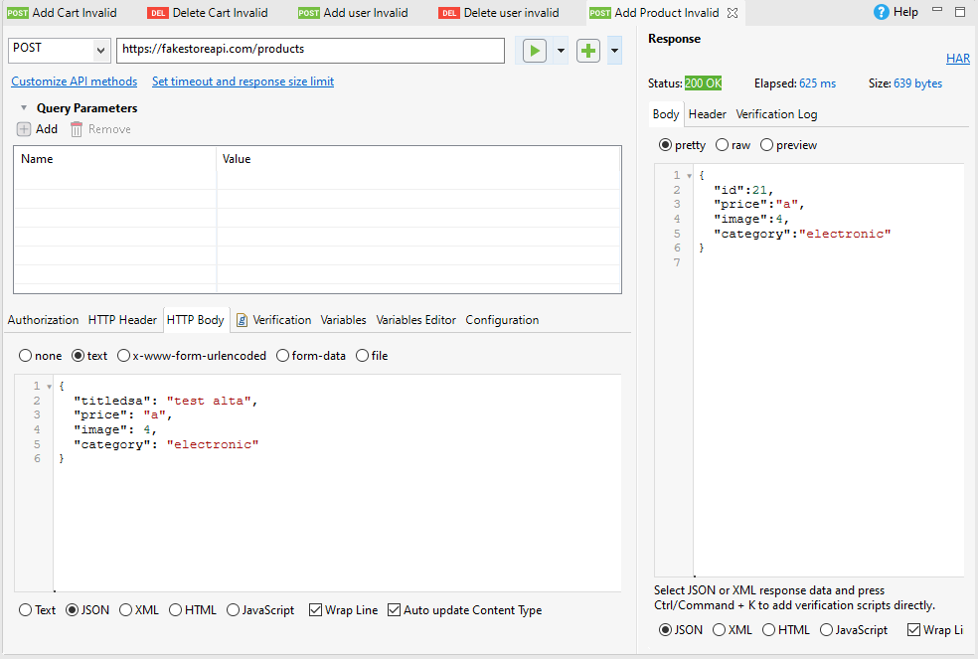

* GET All Product (<https://fakestoreapi.com/products>)

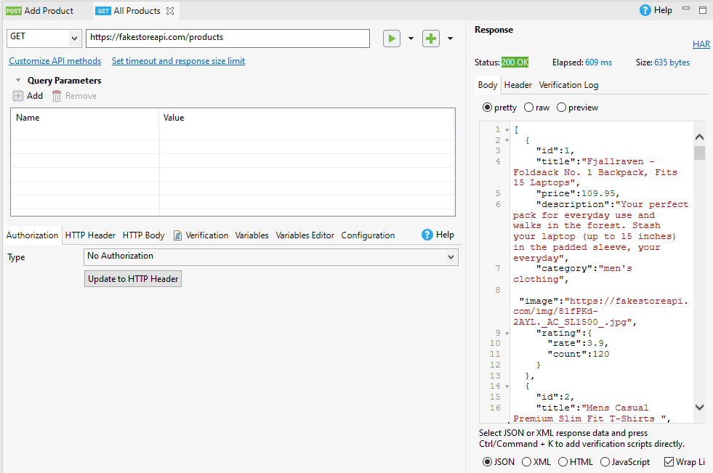

* PUT Edit Product (<https://fakestoreapi.com/products/7>)

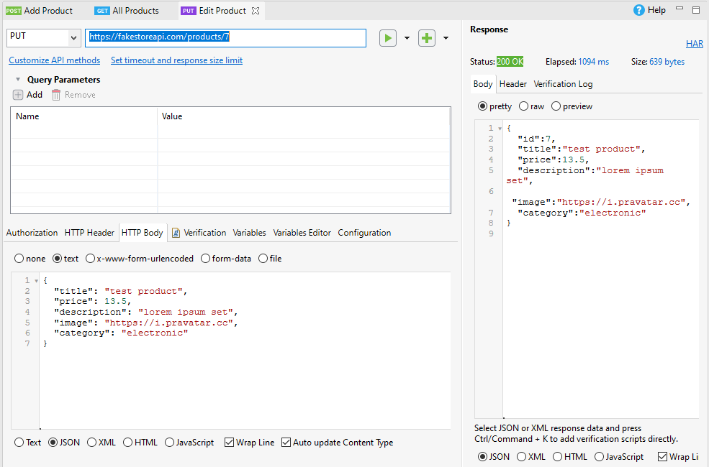

* DELETE Product Valid id (<https://fakestoreapi.com/products/6>)

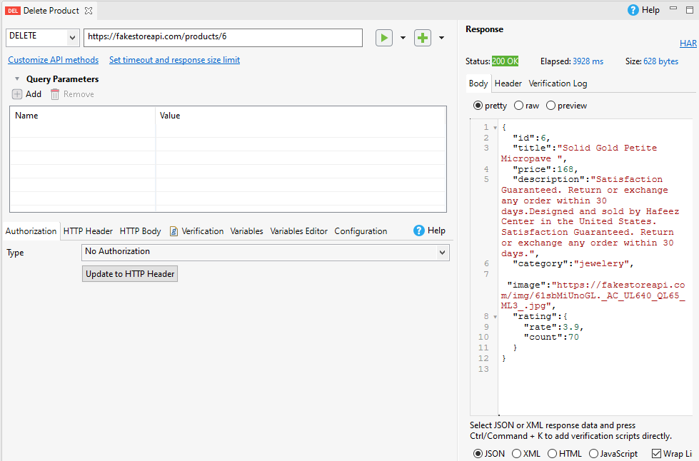

* DELETE Product Invalid id (<https://fakestoreapi.com/products/6>)

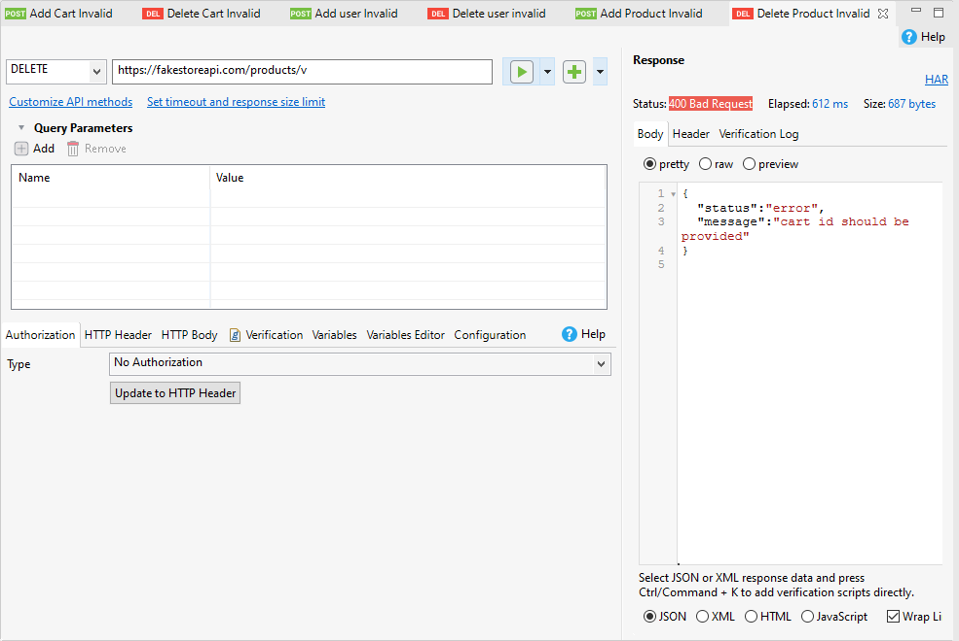

**Test API Fitur Login**

* POST Login Valid data (<https://fakestoreapi.com/auth/login>)

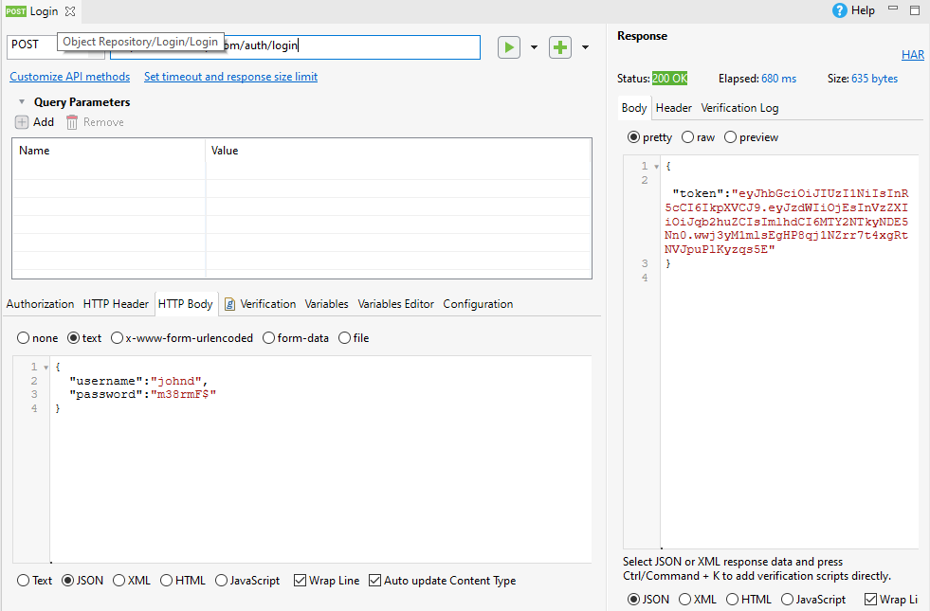

* POST Login Invalid data (<https://fakestoreapi.com/auth/login>)

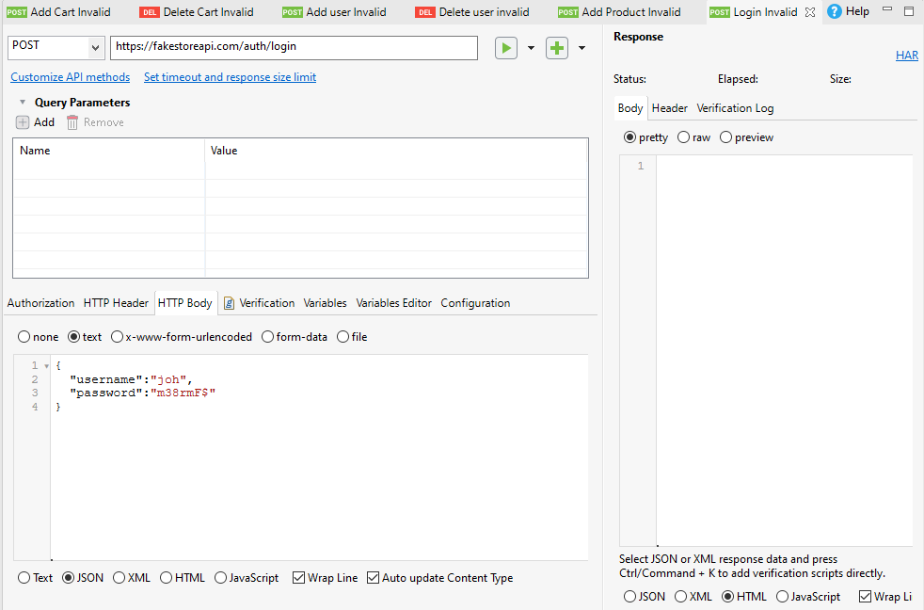

**Feature File**

* User.feature

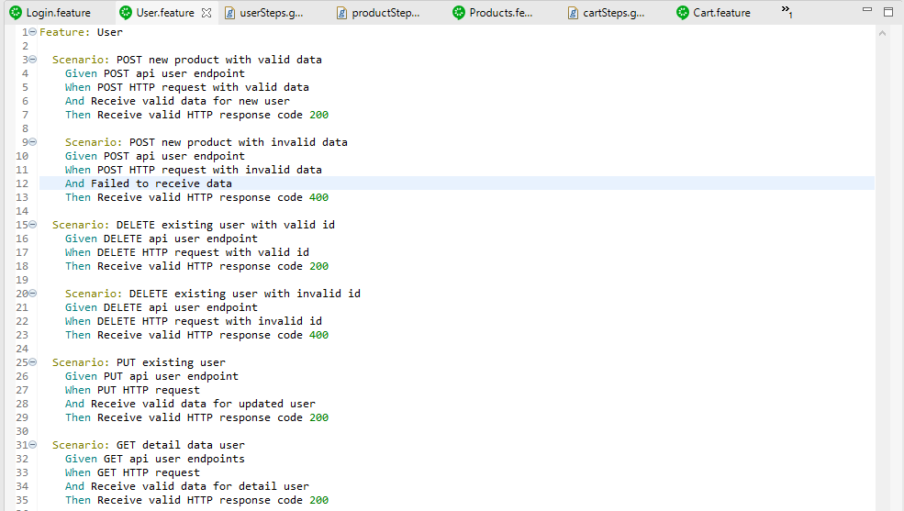

* Cart.feature

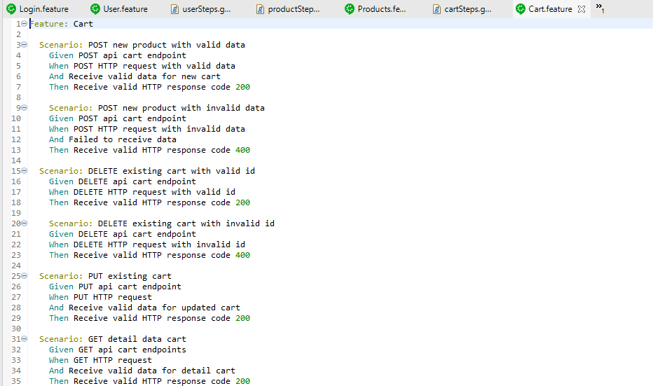

* Products.feature

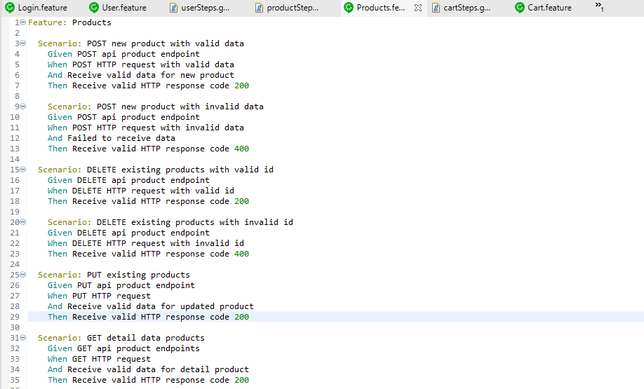

* Login.feature

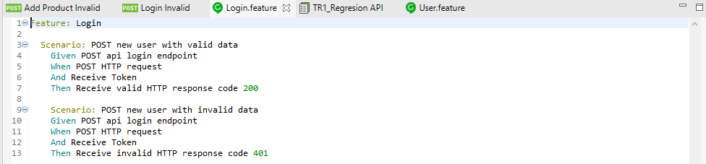

**Test Report**

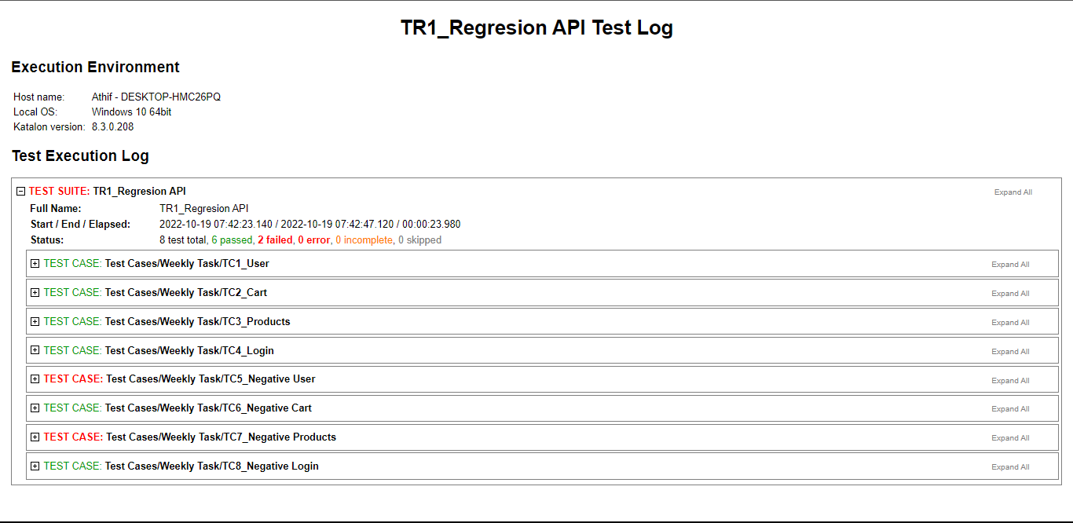

**Test Result**

* User

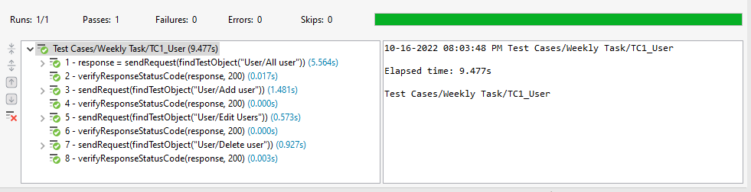

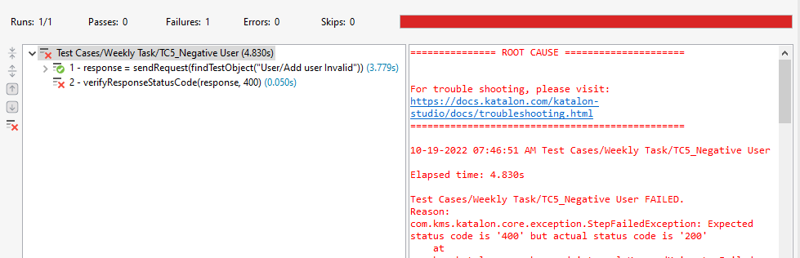

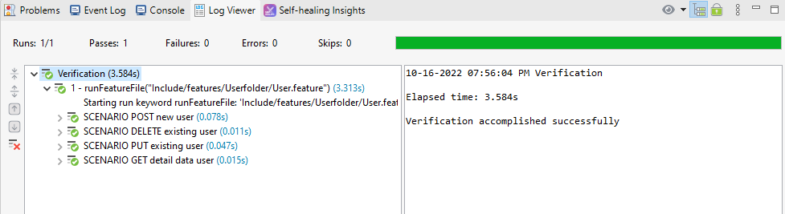

* Cart

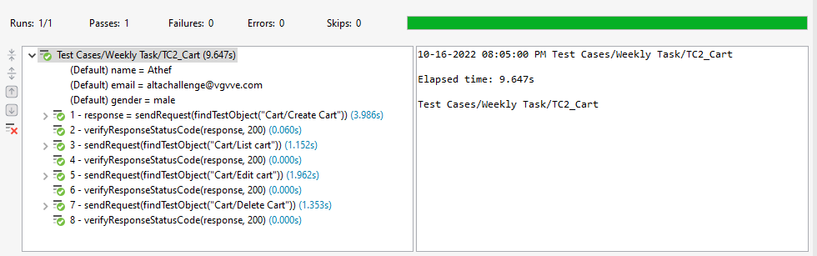

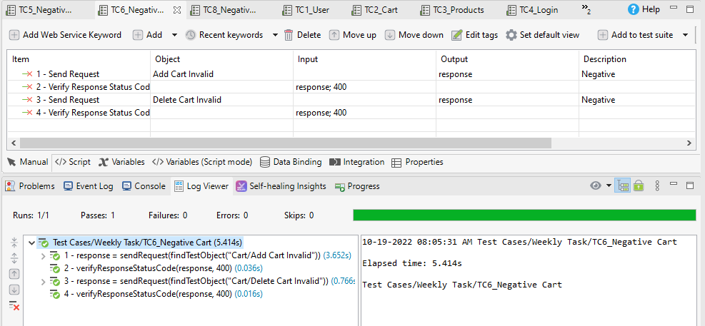

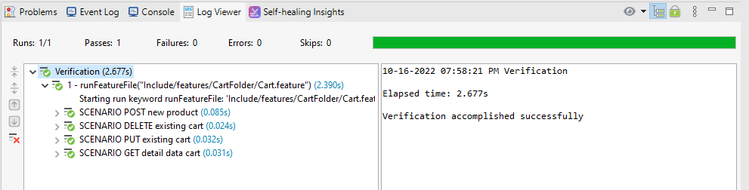

* Product

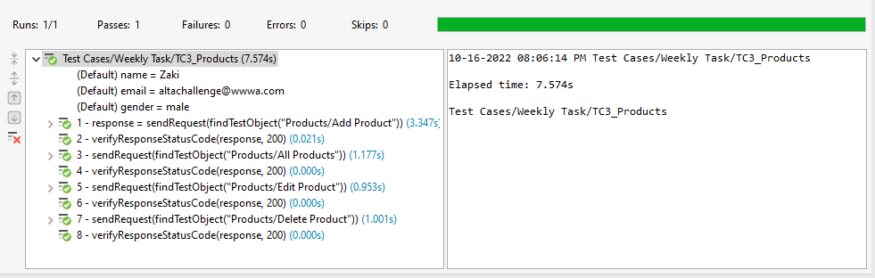

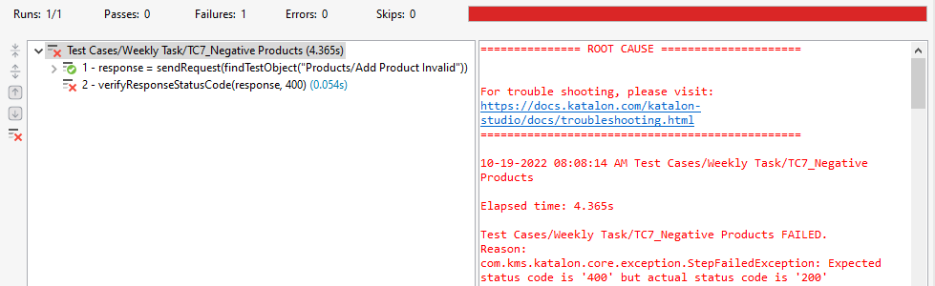

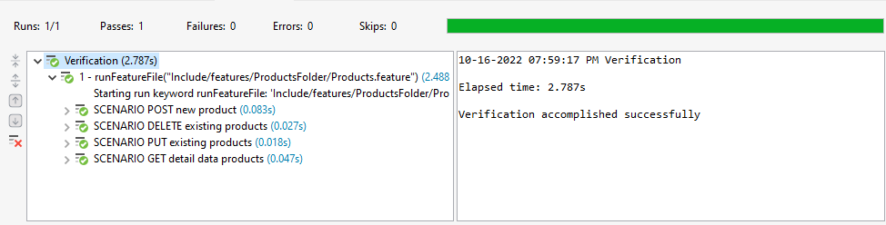

* Login

